UMUKUNZI Rene Christian
29018
PL/SQL
Class Assignment
Step 1: Problem Definition
Business Context
A mid-sized e-commerce company selling consumer electronics. The focus is on Sales and Marketing Analytics.

Data Challenge
We have sales data from different regions and periods but lack insights into product performance, customer behavior, and sales trends.

Expected Outcome
Use SQL JOINs and window functions to find top products, track sales trends, and segment customers to improve marketing and inventory decisions.
Step 2: Success Criteria
- Identify the top 5 products per region by total revenue → RANK()
- Calculate running monthly sales totals per region → SUM() OVER()
- Measure month-over-month sales growth → LAG()
- Segment customers into quartiles based on total spending → NTILE(4)
- Compute a rolling three-month average of sales → AVG() OVER()

Step 3: Database Schema Design
Tables Overview
We design three related tables with PKs and FKs.
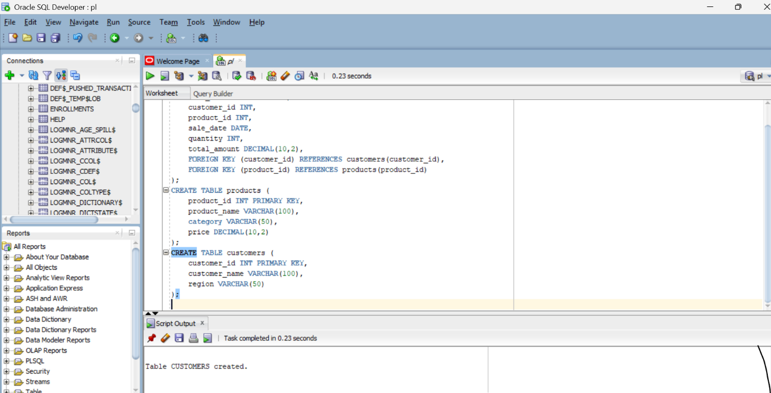
ER Diagram
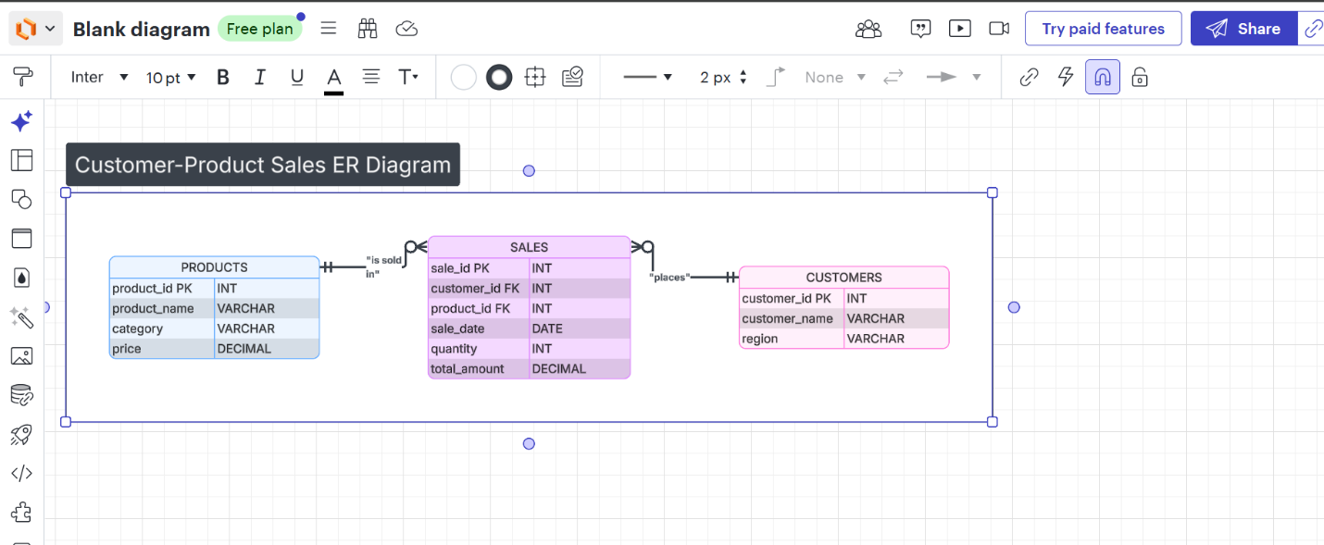
CUSTOMERS ────< SALES >──── PRODUCTS

Step 4: SQL JOINs Implementation
INNER JOIN
Retrieve transactions with valid customers and products
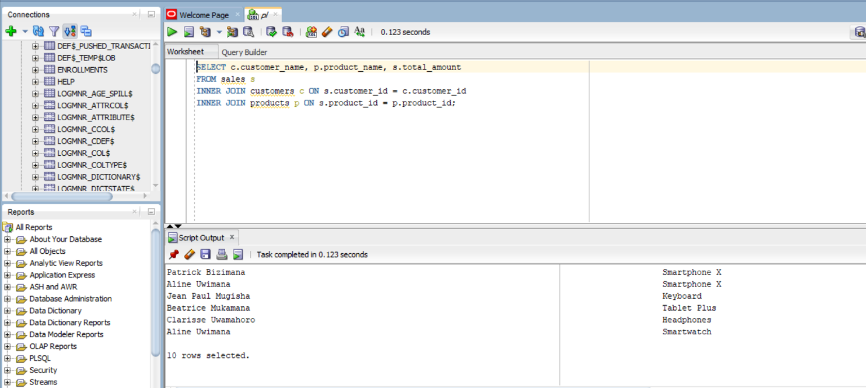
Business Interpretation:
This query shows only valid transactions where both customer and product exist. It ensures data accuracy for revenue analysis.
LEFT JOIN
Identify customers who never made a transaction
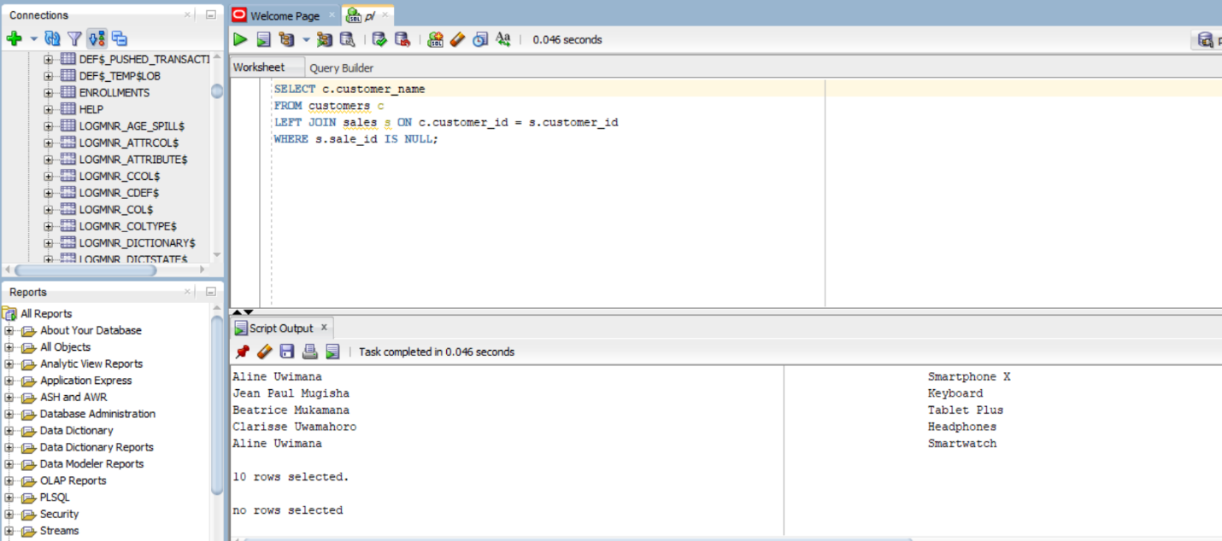
Business Interpretation:
These customers represent inactive users who may be targeted with promotions or re-engagement campaigns.

RIGHT JOIN
Detect products with no sales activity
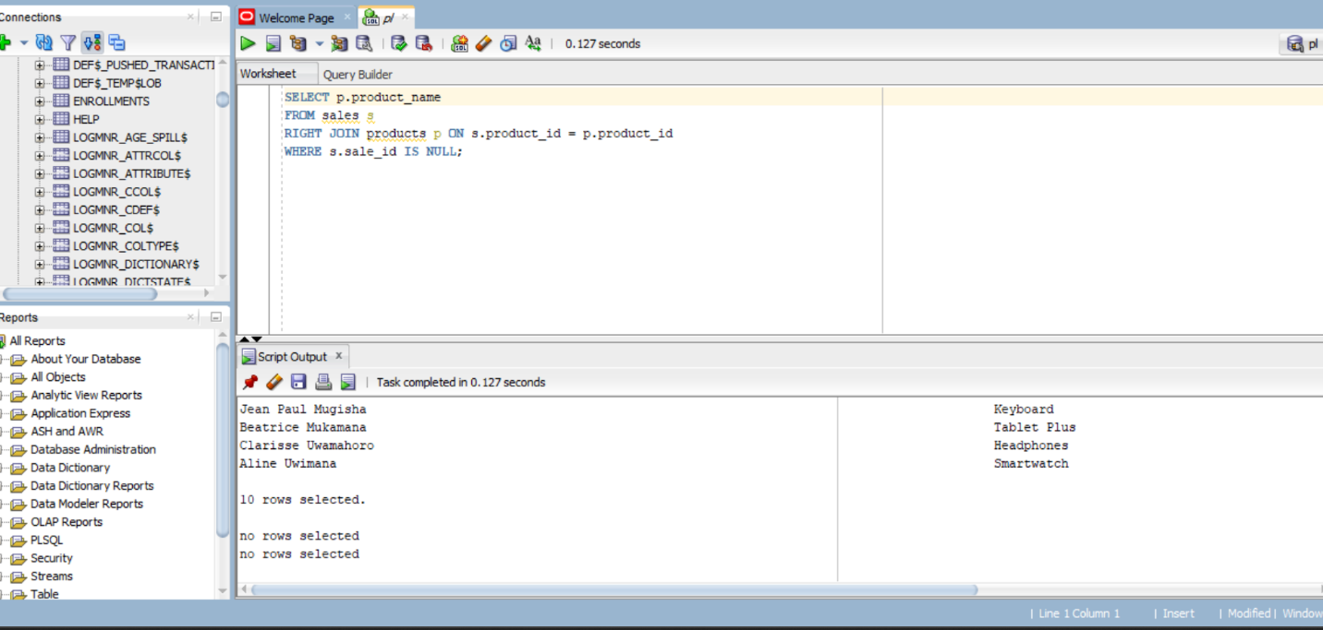
Business Interpretation:
Unsold products may indicate pricing issues, low demand, or poor marketing visibility.

FULL OUTER JOIN
Compare customers and products including unmatched records
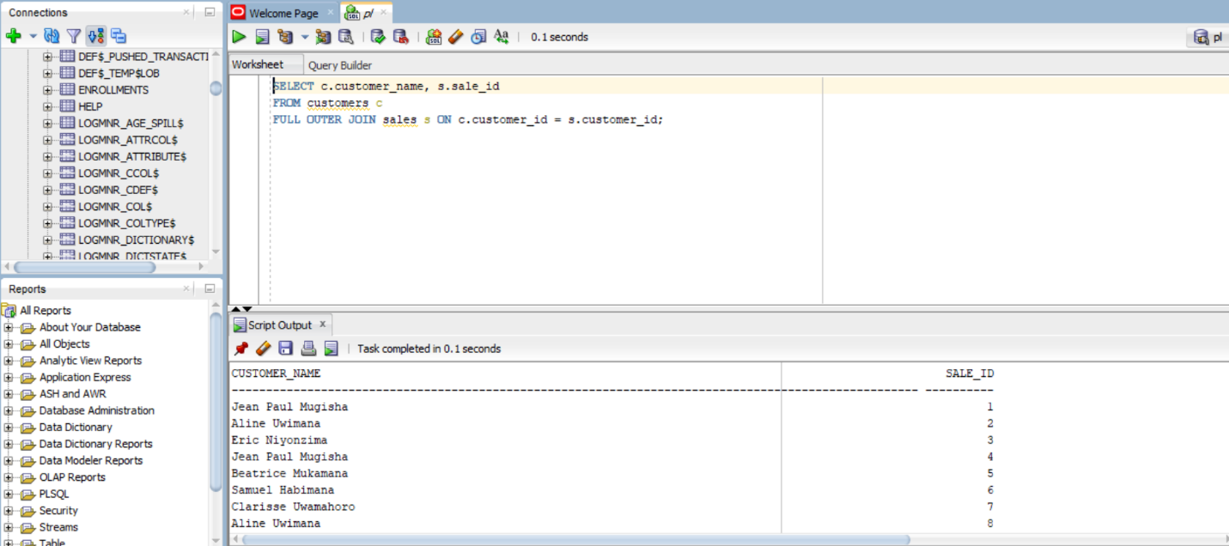
Business Interpretation:
This provides a complete view of matched and unmatched customers and transactions.
SELF JOIN
Compare customers within the same region
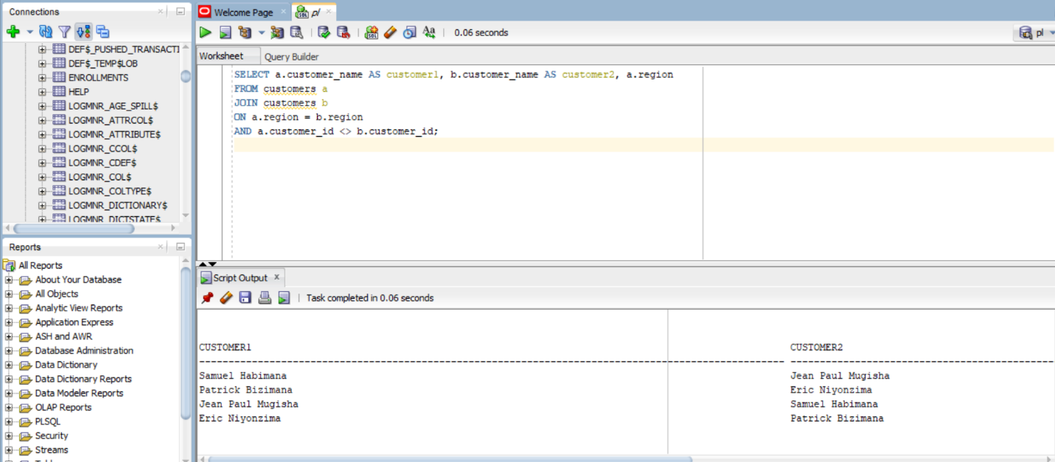
Business Interpretation:
Helps identify customers in the same region for regional marketing or comparative behavior analysis.

Step 5: Window Functions Implementation
Ranking Functions
Top customers by revenue
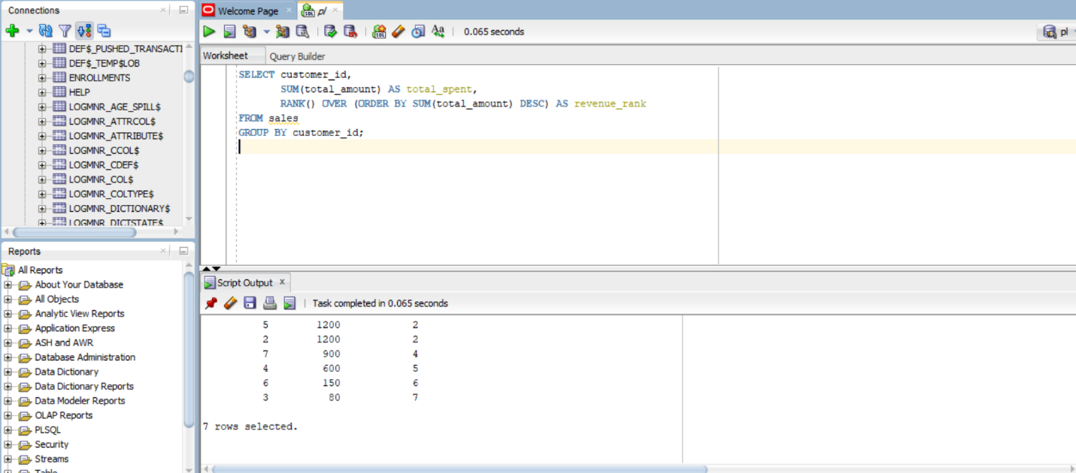Interpretation:
Ranks customers based on spending, enabling identification of top-value customers.

Aggregate Window Functions
Running monthly sales totals
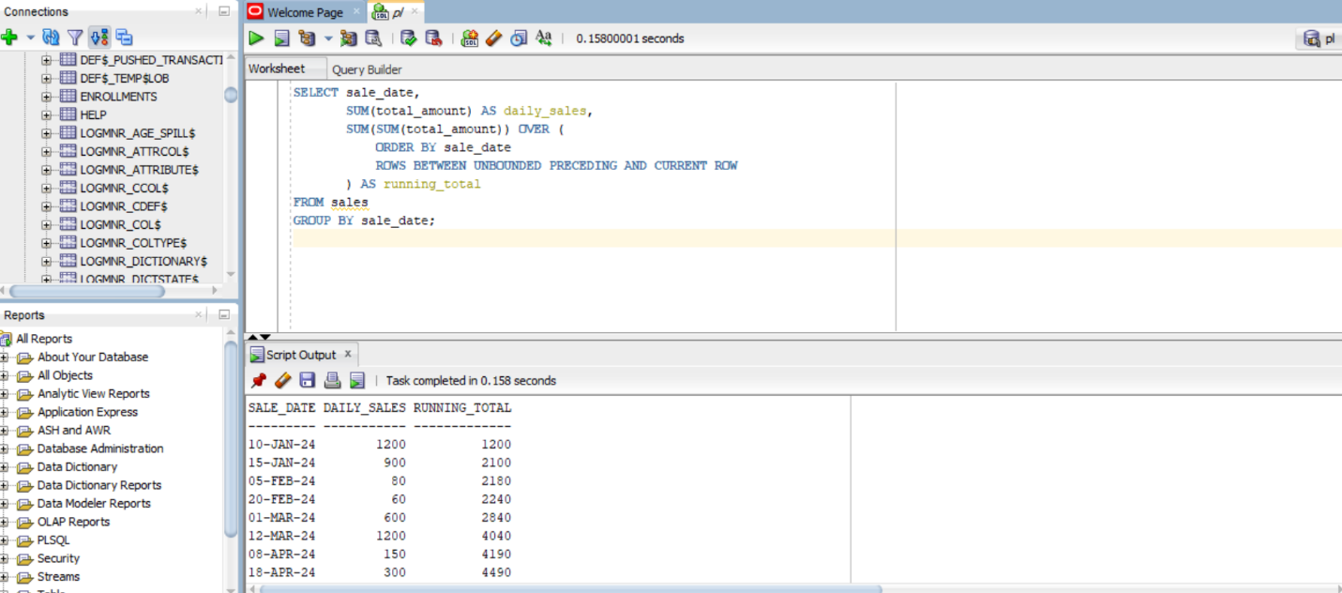Interpretation:
Shows how revenue accumulates over time, revealing sales momentum and trends.

Navigation Functions
Month-over-month growth
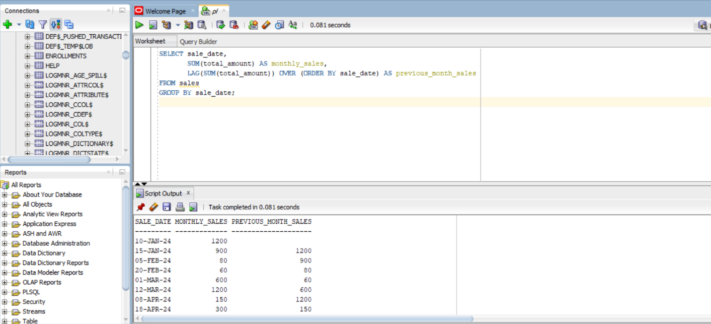Interpretation:
Allows comparison between consecutive months to identify growth or decline.
Distribution Functions
Customer segmentation
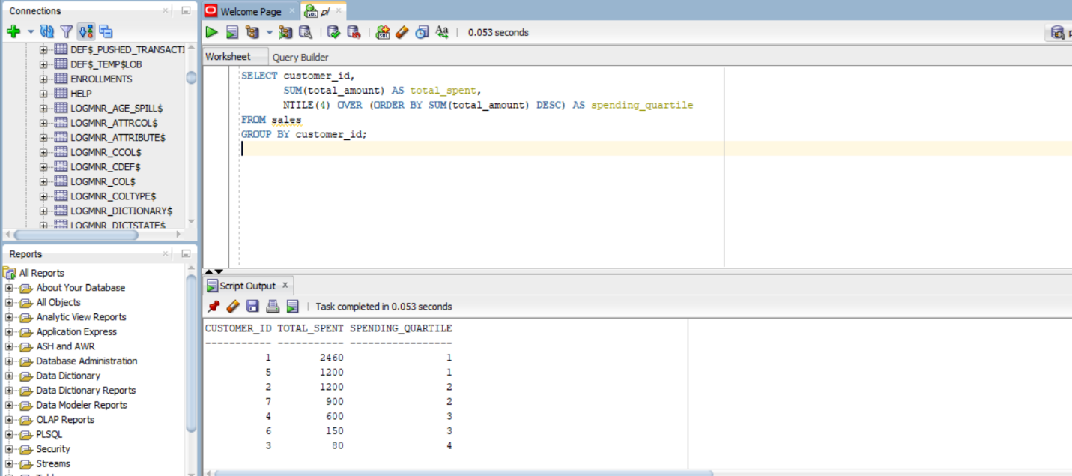Interpretation:
Segments customers into four value groups for targeted marketing strategies.

Step 7: Results Analysis

Descriptive
Top customers and products generated a disproportionate share of revenue, while some products and customers showed no activity.
Diagnostic
High-ranking customers purchase frequently and in larger quantities, while low-performing products lack demand or exposure.
Prescriptive
Focus marketing efforts on high-value customer quartiles, discontinue or reprice underperforming products, and target inactive customers with promotions.

Step 8: References
- Oracle SQL Documentation
- PostgreSQL Window Functions Guide
- W3Schools SQL Analytics
- Class lecture Notes.

All sources were properly cited. Implementations and analysis represent original work. No AI generated content was copied without attribution or adaptation.

